# PF LAB 9

# NAME : Mehreen Fatima

# SAP ID : 63255

# TASK 1:

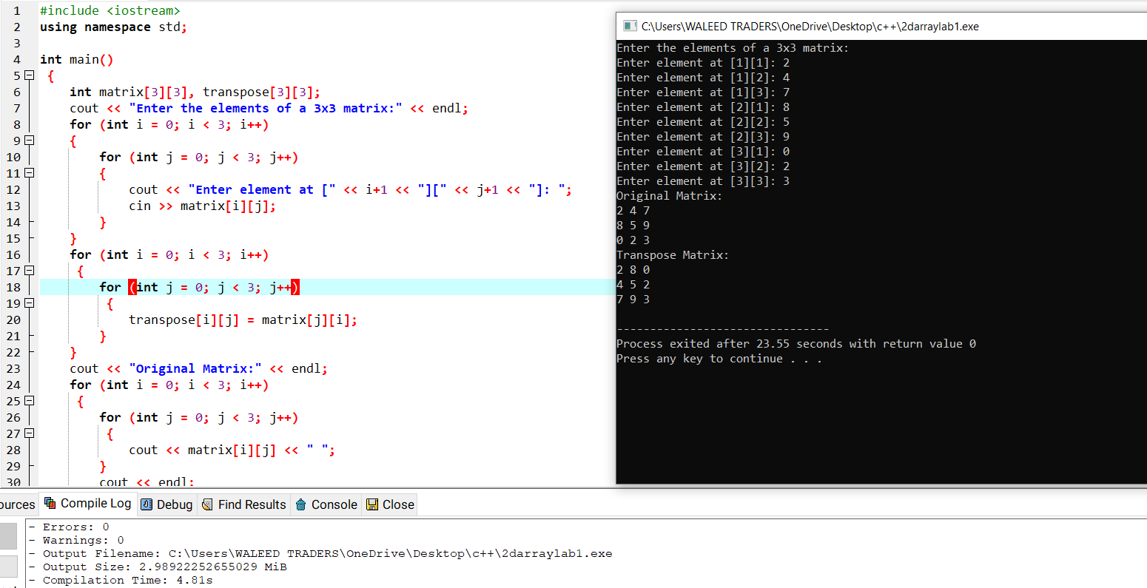

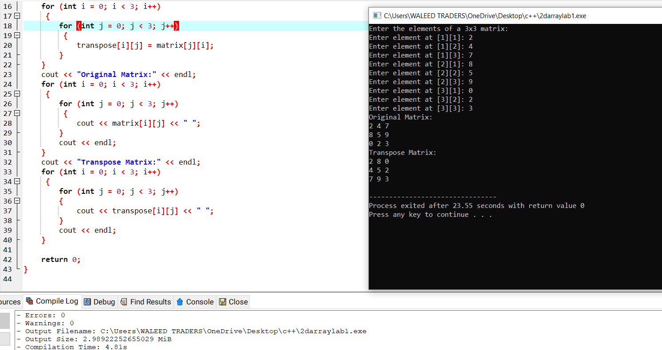

# TASK 2:

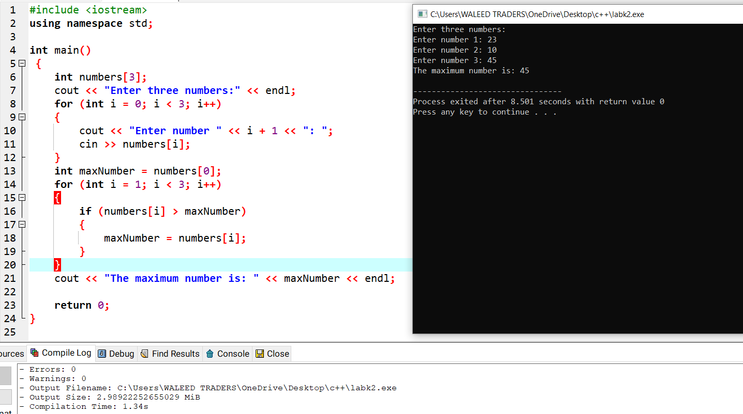

# TASK 3:

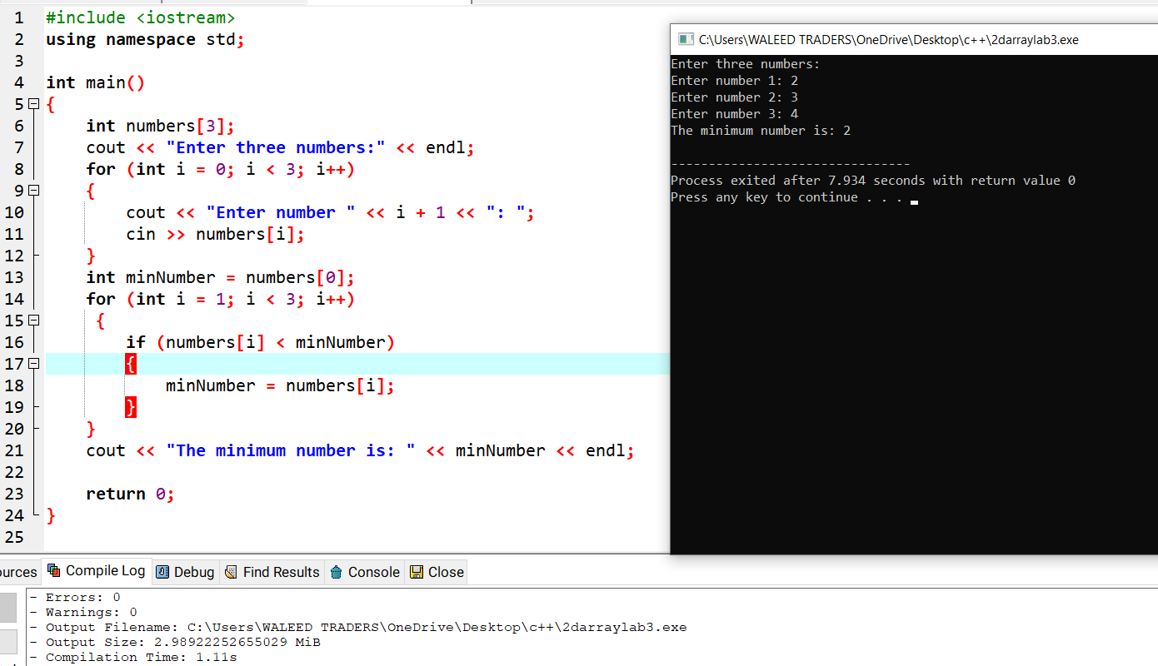

# TASK 4:

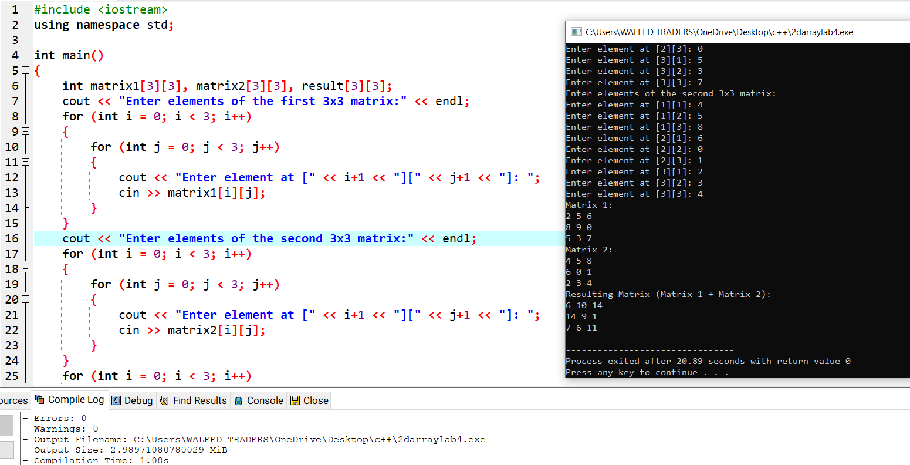

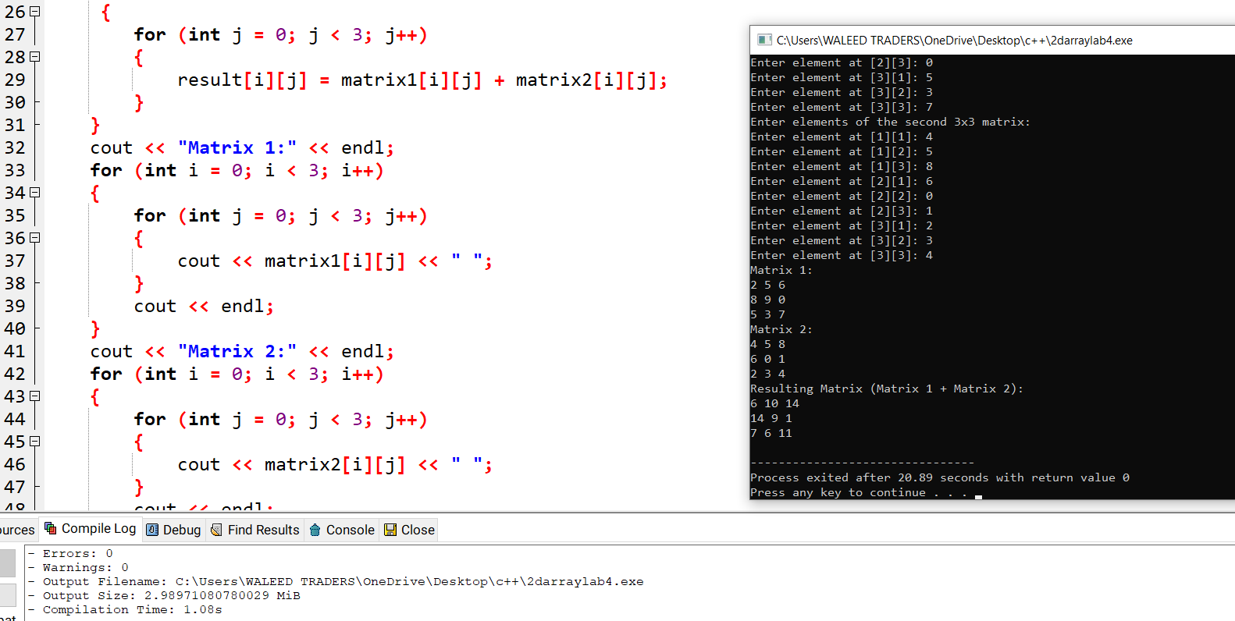

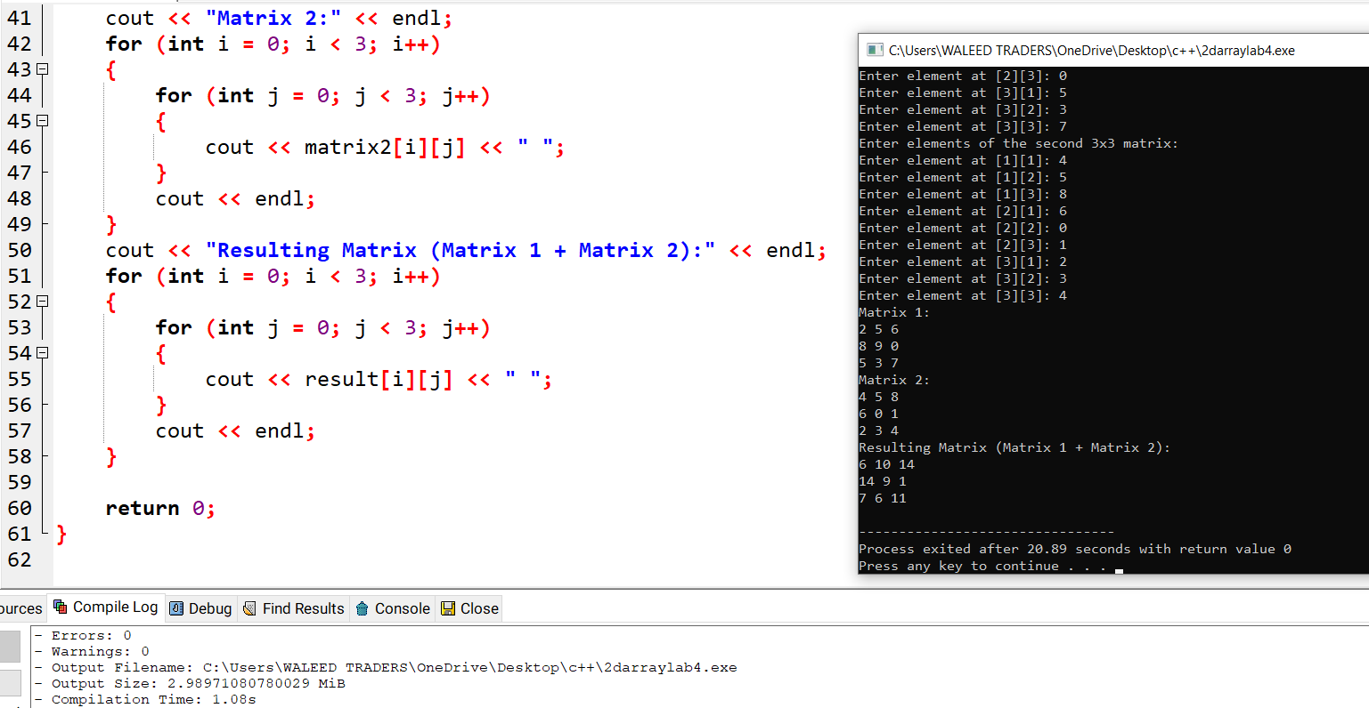

# TASK 5:

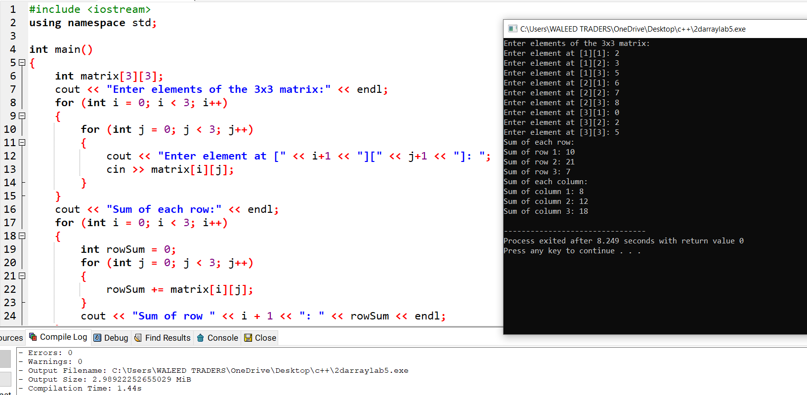

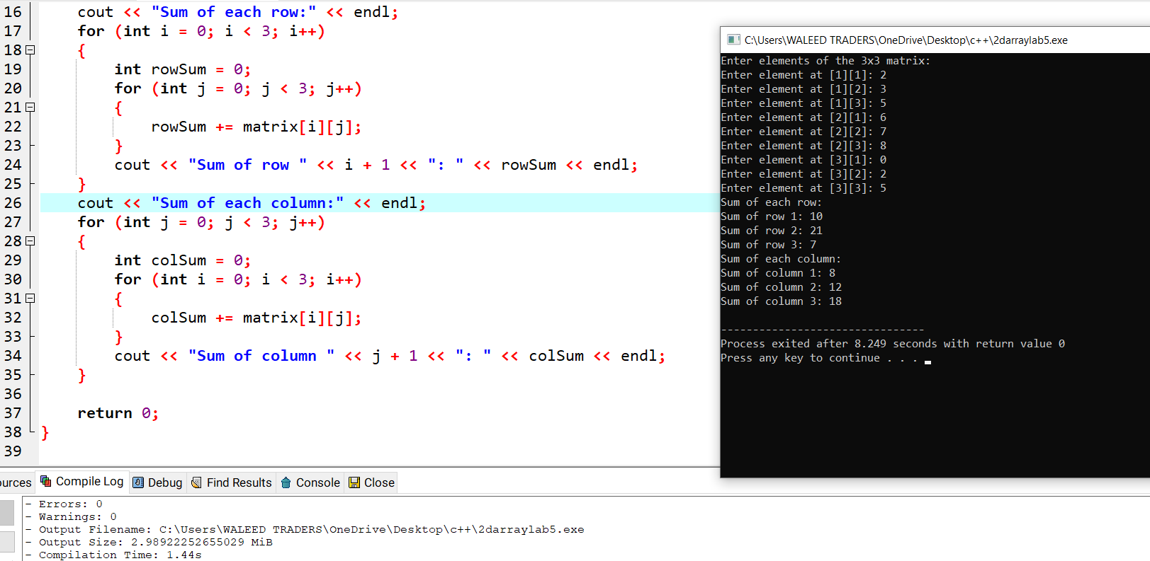

# TASK 6:

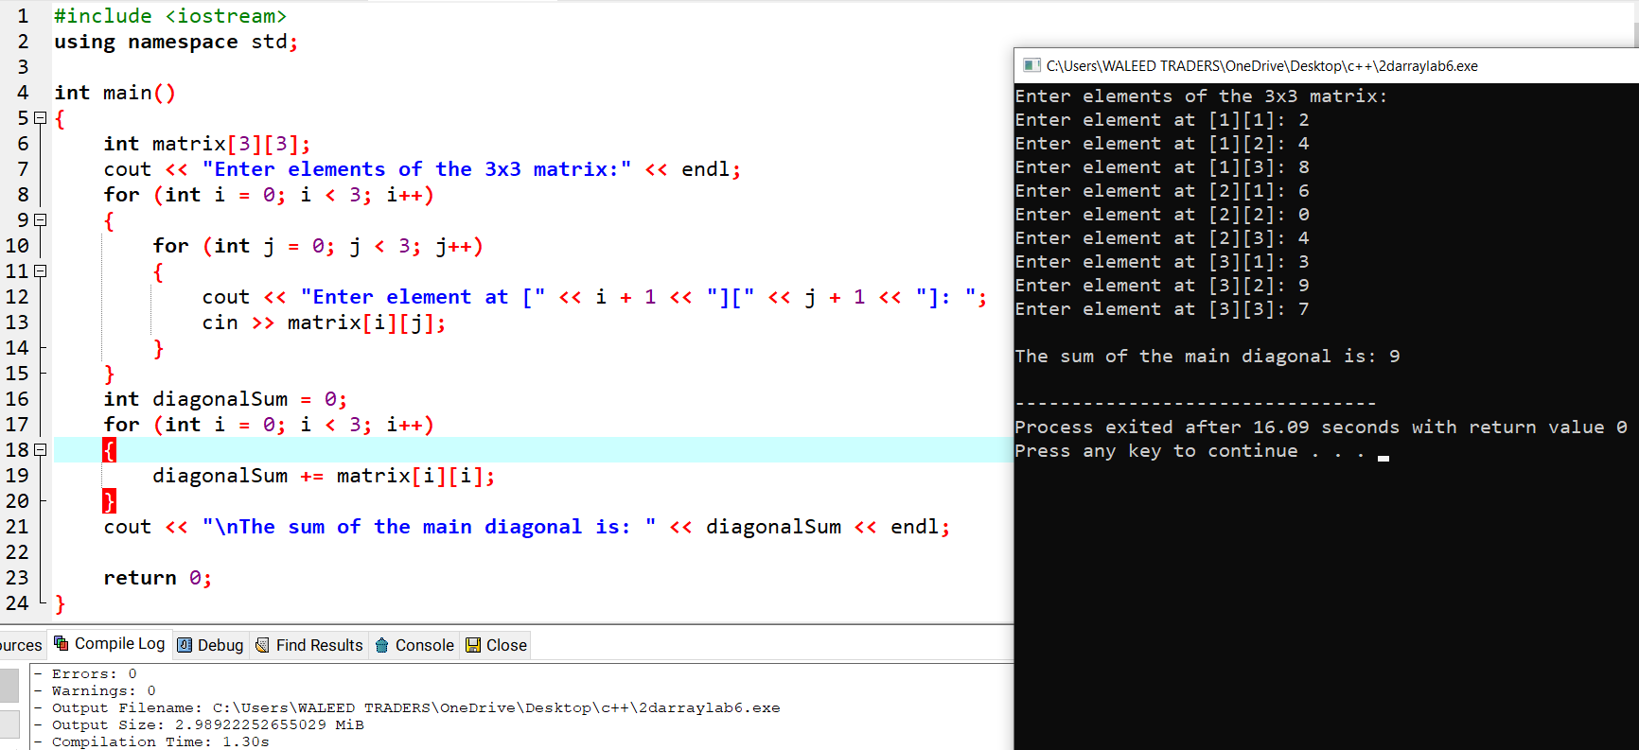

# TASK 7:



